Exhibit 2
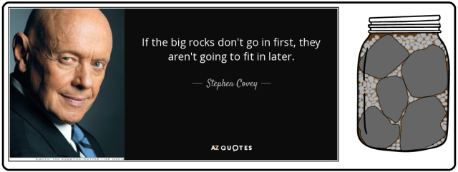
Stephen Covey, perhaps the best-known author and lecturer in the history of the United States of America, taught the importance of prioritizing the largest, the biggest 'functions' using a well-known story in his book First Things First: The Gold Standard of Time Management Books. Read the text of Covey's parable of the rocks via this link: Prioritization of Duties.
“The Main Thing Is To Keep The Main Thing The Main Thing.” ― Stephen R. Covey, First Things First
Steven Covey, in his classic book, First Things First, shares a parable on prioritization that spawned the widely used term “big rocks.” It is the story of an instructor giving a lecture on priorities to his class.
The last paragraph of Stephen Covey's parable:
One student replied, “Well, there are gaps in your day, and if you really work at it, you can always fit more into it.” “No,” the instructor said, “that’s not the point. The point is this: if I hadn’t put the big rocks in first, I would have never gotten any of them in.”

Link to the full parable: Prioritization of Duties: https://rb.gy/4li8f

